In Kenya, and Across Africa, an Unexpected Epidemic: Obesity
Image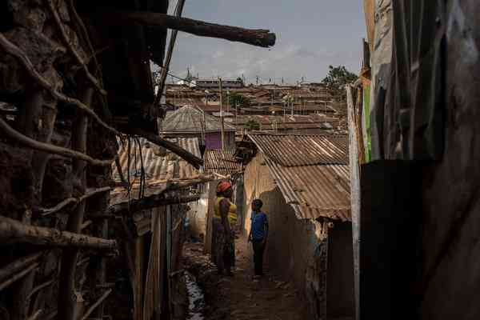
Valentine Akinyi talks with her son, Driffal, 11, outside their Nairobi home in the Kibera section of the city.CreditAndrew Renneisen for The New York Times
By Jeffrey Gettleman
Jan. 27, 2018
NAIROBI, Kenya — As she walks through the alleyways of her poor neighborhood, to a job washing other people’s clothes, Valentine Akinyi weathers the jeers yelled at her: “Elephant, elephant, elephant.”
She has gotten used to the insults, she said, but still, it hurts.
“Who’s going to want to marry me?” she asked.
It used to be difficult in Kenya to find many people built like Ms. Akinyi, who, at 5 feet 9 inches tall and 285 pounds, is obese.
In Africa, the world’s poorest continent, malnutrition is stubbornly widespread and millions of people are desperately hungry, with famine conditions looming in some war-torn countries.
But in many places, growing economies have led to growing waistlines. Obesity rates in sub-Saharan Africa are shooting up faster than in just about anywhere else in the world, causing a public health crisis that is catching Africa, and the world, by surprise.
In Burkina Faso, the prevalence of adult obesity in the past 36 years has jumped nearly 1,400 percent. In Ghana, Togo, Ethiopia and Benin, it has increased by more than 500 percent. Eight of the 20 nations in the world with the fastest-rising rates of adult obesity are in Africa, according to a recent study by the Institute for Health Metrics and Evaluation at the University of Washington.
It is part of a seismic shift in Africa as rapid economic growth transforms every aspect of life, including the very shape of its people.
Many Africans are eating more junk food, much of it imported. They are also getting much less exercise, as millions of people abandon a more active farming life to crowd into cities, where they tend to be more sedentary. More affordable cars and a wave of motorbike imports also mean that fewer Africans walk to work.
Image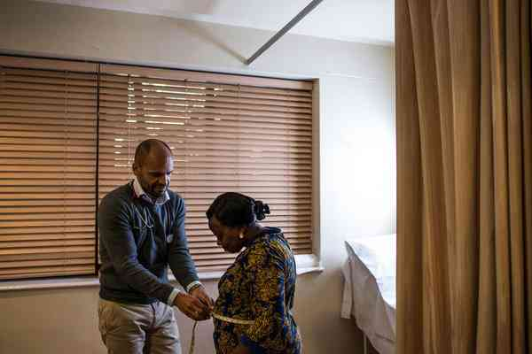
Dr. Anders Barasa, a cardiologist, measures a patient’s waistline during an appointment at the heart clinic at Aga Khan University Hospital in Nairobi.CreditAndrew Renneisen for The New York Times
Obesity may be an especially tough battle in Africa for other reasons. For one, people who did not get enough nutrients when they were young (which is still a problem in Africa) are more prone to putting on weight when lots of food is available. And second, African health systems are heavily geared toward combating other diseases.
African doctors say their public health systems have been so focused on AIDS, malaria, tuberculosis and tropical fevers — historically, Africa’s big killers — that few resources are left for what are called noncommunicable diseases, like diabetes and heart ailments.
“What we are seeing is likely the worst epidemic the country will ever see, probably in the long run worse than the H.I.V. epidemic of the ’90s,” said Anders Barasa, a cardiologist in Kenya, referring to obesity and its related diseases. “But changing the health care system to cater for obesity related diseases is like turning a supertanker.”
In Kenya, one of Africa’s most developed nations, there are around 40 cardiologists for the entire population of 48 million people. In the United States, there is one cardiologist for every 13,000 people.
Even as the obesity problem worsens, Africa’s older problem of malnutrition has hardly vanished. While millions of Africans are eating unhealthy foods or overeating, millions of Africans are still starving or near to it.
Last year was one of the worst on record for hunger. In March, United Nations officials warned that famines could break out in three different African countries— Somalia, Nigeria and South Sudan — because of wars and long dry spells.
Full-blown famines have not materialized, because aid agencies got to the hardest hit places quickly enough. But thousands have died from a cholera epidemic catalyzed by malnourished people streaming into camps, and famine still stalks a large part of Africa.
Health professionals say that people who grow up deprived of nutrients, as millions of Africans do, run a higher risk of later becoming obese. During famine times, one of the body’s defense mechanisms, some experts say, is to slow down metabolism to hold onto every calorie.

Samuel, 13, center, the son of Fraciah Wangari, exercising during a physical education class at Muthaiga Primary School in Nairobi. He is teased about his weight.
When feast times come, metabolism often remains slow. Such metabolic disorders can lead to all kinds of health problems later on, some of them life threatening.
One leading Kenyan endocrinologist, Nancy Kunyiha said that when she started a diabetes practice years ago, her medical school colleagues thought she was crazy.
“ ‘There’s no way you can survive off diabetes,’ ” she said they warned her. “ ‘You got to do something else.’ ”
But Type II diabetes is closely linked to obesity, and sub-Saharan Africa is in the midst of a “rapidly expanding diabetes epidemic,” according to a report last year in a medical journal, The Lancet Diabetes & Endocrinology.
ADVERTISEMENT
In the past decade, Dr. Kunyiha’s diabetes practice has quadrupled, and most days, her brightly lit, no-frills waiting room at the Aga Khan hospital in Nairobi, Kenya’s capital, is standing room only.
Kenya’s obesity rate, which is close to one in 10 people, is still far below industrialized countries like the United States (where more than one-third of adults are obese). But Kenya’s rate is rising fast, more than doubling since 1990, and many Kenyans are thinking about obesity for the first time.
Ms. Akinyi says she reads any article in the local papers about “lifestyle diseases,” as obesity and hypertension are often referred to here. But what the writers recommend to lose weight, she cannot afford.
She is a high school dropout, a single mother and a washerwoman; on about $40 a month, she supports herself and three children. Millions of Africans are just like her: trapped between the old and the new. They might not be destitute like their parents were. But they are still poor.
Image

People eating at Burger King at the The Hub, an upscale shopping mall in the Karen neighborhood of Nairobi. The Hub has a variety of Western fast food options including Burger King and Dominos.CreditAndrew Renneisen for The New York Times
While they have just enough money to buy processed foods like potato chips, which are now widely available in low-income areas for a few cents, they often do not have enough to join a gym or buy fish or fresh vegetables.
And instead of working in the fields (which is how most Kenyans lived just a generation ago), they are marooned in squalid urban areas and are less physically active. Some of the least expensive foods to buy in the Kibera slum where Ms. Akinyi lives are French fries and fried dough, each around 20 cents. Apples, at the equivalent of 40 cents, are outside her budget, though soda isn’t.
“And I love Sprite,” Ms. Akinyi said with a guilty smile.
One of Coca-Cola’s strategies in Kenya has been to reach the lower economic classes by making smaller 200 milliliter bottles, or about 6.75 fluid ounces, that cost about 15 cents (compared with the standard 300 milliliter bottle that costs 25 cents). Burger King, Domino’s, Cold Stone Creamery and Subway have all recently opened their first stores in Kenya, part of their strategy to break into Africa.
Despite insults like “elephant,” there is also a stigma to being thin in some Kenyan circles. It goes back generations but was especially true in the 1990s, at the height of the AIDS epidemic when millions of Africans died.
To many Kenyans, Dr. Kunyiha said, being thin still means being poor or sick.
“It’s really frustrating,” Dr. Kunyiha said. “The image here is: The bigger your tummy, the better you’re doing.”
One of her patients, she says, is a rich man who drives a Mercedes and suffers from hypertension and obesity. She keeps telling him to switch from fast food and meat to the old fashioned Kenya diet of beans, carrots and a vegetable called sukuma wiki that is similar to kale.
“But he tells me he’s come too far to eat like that because that’s what he ate when he was a poor kid,” she said.
Dr. Barasa has had many similar conversations with his patients. “I tell people: ‘Eat like your grandmum did. It’s so much better for you,’ ’’ he said.
Image
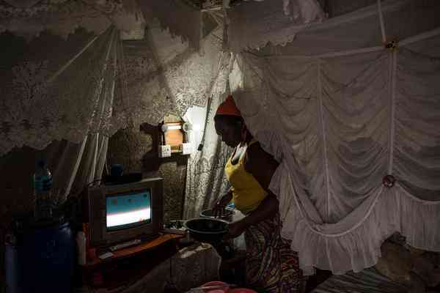
Ms. Akinyi prepares dinner for her family at home. She can afford French fries and fried dough, but apples are outside her budget.CreditAndrew Renneisen for The New York Times
Several Kenyan parents said they felt deeply conflicted about restricting their children’s diet. Fraciah Wangari grew up in a poor village and does not want to deny her son.
“I remember what it was like to really want biscuits but not be able to afford them,” she said.
So she indulges her only child, Samuel, 13, who is obese, with a plump round face and a big belly. He’s beginning to have circulation problems and says his joints hurt. He gets called animal names, too, like buffalo and pig.
Ms. Wangari recently splurged for a doctor’s visit but many of the nutritious foods the doctor suggested, like fish, were way beyond her budget.
Affluent Kenyans have more options. It is not uncommon in Nairobi’s fancier neighborhoods to see middle-aged men and women jogging their way up the hills, decked out in bright spandex. Just 10 years ago that was an unusual sight.
The Kenyan government, like other African governments, seems to have been slow to recognize the problem. The Health Ministry is still much more focused on promoting protected sex than good nutrition.
Africa is urbanizing faster than any other region of the world. In 1980, only 28 percent of Africans lived in urban areas. Today, that number is 40 percent, and by 2030, it is predicted to be 50 percent.
The urbanization is driven partly by high birthrates and a shrinking availability of land, creating an exodus of millions of Africans from rural areas.
“If you’re working in the field eight hours a day, you can eat anything you want,” Dr. Barasa said. “But if you’re sedentary, your requirements totally change.”
Many Kenyans used to walk miles a day to work or to school. But the road network has vastly improved, and it is now much easier to travel via minibus. Countless Kenyans also use motorcycle taxis, which were not widely available 10 years ago.
Ms. Akinyi, 30, said she still enjoyed walking.
“It’s a way to get to work and get a little exercise,” she said.
Best of all: It is free.
https://www.nytimes.com/2018/01/27/world/africa/kenya-obesity-diabetes.html?smid=tw-nytimesworld&smtyp=cur

