The Interwar Years (1919-1938)
With the end of World War I, the old international system was torn down, Europe was reorganized, and a new world was born. The European nations that had fought in the Great War emerged economically and socially crippled. Economic depression prevailed in Europe for much of the inter-war period, and debtor nations found it impossible to pay their debts without borrowing even more money, at higher rates, thus worsening the economy to an even greater degree. Germany especially was destroyed economically by World War I and its aftermath: the reparations to Britain and France forced on Germany by the Treaty of Versailles were impossibly high.
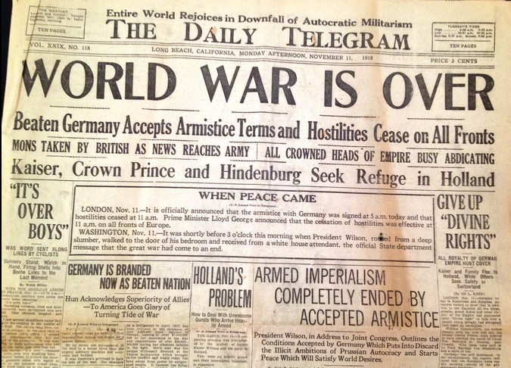

The League of Nations represented an effort to break the pattern of traditional power politics, and bring international relations into an open and cooperative forum in the name of peace and stability. However, the League never grew strong enough to make a significant impact on politics, and the goals of deterrence of war and disarmament were left unaccomplished.
The political atmosphere of the inter-war years was sharply divided between those who thought the extreme left could solve Europe's problems, and those who desired leadership from the extreme right. There were very few moderates, and this situation kept the governments of Britain, France, and Eastern Europe in constant turmoil, swinging wildly between one extreme and the next. Extreme viewpoints won out in the form of totalitarian states in Europe during the inter-war years, and communism took hold in the Soviet Union, while fascism controlled Germany, Italy and Spain.
The extremist nature of these disparate ideologies turned European politics into an arena for sharp conflict, erupting in Spain during the late 1930s in the form of the Spanish Civil War, after which Francisco Franco became dictator. In Germany, Adolf Hitler's fascist Nazi Party came to power during the 1930s and prepared once again to make war on Europe. With Britain and France tied up in their own affairs, the path to World War II lay clear.

The inter-war years refer to the pivotal 20 years that fell between the end of the First World War and the Second World War. The effects of World War One were profound for Europe. Ten million were killed and twice that number wounded in what has been dubbed the first modern war. All of the wars of the hundred years leading up to World War One had claimed a total of only four and one-half million lives. During the Great War, the French averaged a death each minute. The destruction of a generation in Europe left many of those lucky enough to survive psychologically scarred, and many would find it hard to lead normal lives.
In addition to the toll taken on European life, both the victorious Allies and the defeated Central Powers were saddled with enormous national debts, which contributed to the financial insecurity that was to plague all of Europe during the inter-war period. The land of Europe was physically devastated, and the three great European empires--Germany, Austria-Hungary, and the Ottoman--were toppled by the war and lay in ruins. Soldiers of both sides returned home to this devastation and found only rampant unemployment and despair. The widespread destruction led to internal political conflict and social instability in almost every nation in Europe during the inter-war period.
The diplomatic results of the First World War greatly determined the nature of European affairs during the inter-war years. The Paris Peace Conference dismantled large blocs of territory in Eastern Europe and drew the boundaries for new, independent states. These new states were in many cases not economically viable, due to the destruction of the war, and past reliance on the economies of the empires. Additionally, these countries were unused to democracy and independence, and many were divided internally by factions and antagonistic ethnic groups. Moreover, the rise of radical political groups meant a wider spectrum of political ideologies clamoring for acceptance. The ideologies of both fascism and communism attracted more followers during the inter-war years than ever before. All of this made the task of good government difficult, if not impossible, throughout Eastern Europe. Instability and poorly operating, often-dictatorial governments were typical of these states, making them easy targets for a rearmed Germany during the late 1930s.
Germany, for its part, was crippled not only by the war, but also by the settlement of the war, in which it was scapegoated as the conflict's aggressor. The Treaty of Versailles provided for the military and economic dismemberment of the German states, along with the requirement of impossible reparations payments to Britain, France, and the other allied nations. France, having suffered the greatest destruction at the hands of the Germans during World War One, was adamant about keeping Germany weak, and demanded reparations without exception in the years following the Great War. Due in great part to these efforts, Germany suffered through starvation, mass unemployment, and rampant inflation, all made unbearable by the Great Depression. Naturally, Germans reacted bitterly toward their foreign oppressors and dreamed of a return to the glory of the German Empire. It was this dream which permitted the ascension of Adolf Hitler and the Nazi Party to power in Germany, promising a future of glory and European domination. Under the Nazis, Germany rearmed and began a program of European conquest, which at first was permitted by the former Allies, in hopes of avoiding a second war. However, it soon became clear that Germany's intentions were dangerous to European security, and just twenty years after the "War to End all Wars," Europe fell again into devastating conflict.

Follow-up tasks:
1. Why did Italy turn to Fascism in the years following World War I?
2. Some historians claim that Europe's failure to rebound from the First World War was caused by the extensive loss of lives, especially those of the intellectual elites during the war. Evaluate this 'lost generation' theory.
3. How did the League of Nations demonstrate changing concepts of international relations?
4. Why were extremist political parties more successful during the inter-war years than they had been before World War One?
5. What lessons did the international community learn from WWII? Try to employ a critical perspective stemming from social constructivism. Has the world become too interconnected to witness another systemic conflict?
Adapted from: http://www.sparknotes.com/history/european/interwaryears/context/

