A Brief Introduction to Bollywood
Bollywood movies may or may not help learning Indian life and culture, but this little article would sure help supplying a brief Bollywood introduction.

Introduction
The word Bollywood stands for the Mumbai based Hindi film industry. Bollywood = Hollywood + Bombay (the former name of Mumbai). Although, Bollywood refers the Hindi film industry only, this term is often used for the whole Indian film industry, which is technically incorrect. Although Bollywood is a very popular and widely used term, but there are many who do not express happiness about the term, for it is derived from ‘Hollywood’.
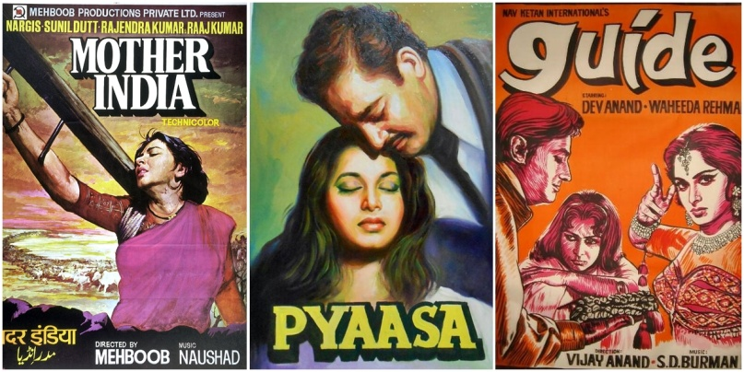‘Mother India’ (1957), ‘Pyaasa’ (1957), and ‘Guide’ (1965) are among the finest Bollywood movies of all time

The Indian film industry is the leading film industry in the world if we look at the number of movies produced every year. And, probably if we look at the count of viewers, as well.
While Bollywood is well known for its very dramatic masala movies and romantic movies, Bollywood also produces a number of movies possessing social realistic story-line and sensible topics.

The Mainstream Movies: Masala and Romantic Movies
The Masala Movies are considered to be the most popular genre in Bollywood. ‘Masala’ is a Hindi word for spice, or mixture of numerous ingredients to make a desired mix. So, the term Masala can be taken as Hindi equivalent of the English term ‘formula’. Masala movies contain drama, action, romance, comedy, sadness, happiness, and everything. Songs are also integral part of the Masala films.
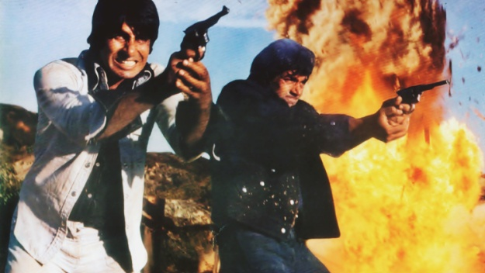‘Sholay’ (1975), a complete masala movie, is biggest Bollywood hit ever
Romance in real life isn’t very commonplace in India, but romantic movies are extremely flourishing. A large portion of total films produced every year is occupied by love-stories. These love-stories are often the struggle of a couple in a conservative society and sometimes just fairy tales. Romantic love triangle is also a favourite topic of Bollywood.

Non-mainstream Movies and Parallel Cinema
However Masala and romantic movies are the face of Bollywood and Indians really enjoy them, there is also a herd of people who loathe such movies and want something sensible.
There is a segment of Bollywood movies, produced by smaller production houses, generally directed and acted by lesser known artists. These low budget movies are highly praised for their quality of story-line and topic. These movies are known for their more accurate portrayal of Indian life and culture compared to the mainstream movies.
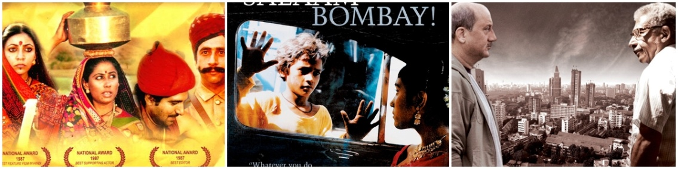‘Mirch Masala’ (1987), ‘Salaam Bombay’ (1988), and ‘A Wednesday’ (2008) are among notable non-mainstream movies
The Parallel Cinema is trend running since the early days the Indian cinema industry, which advocates social realistic films. These movies are also often called ‘Art films’. Parallel cinema, although not commercially very successful, is well respected for its intellectual touch.

Brief History of Bollywood
Bollywood is one year older than Hollywood. Silent movie ‘Raja Harishchandra (1913)’ by Dada Sahab Falke was the first movie produced in India. First talking movie was ‘Alam Ara’ (1931).
The time period between the year of India’s independence (1947) to late 60s is regarded as the Golden Period of Bollywood. By the end of this age movie had begun turning into colour. Movies in this period were social drama and romantic. Masala term hadn’t yet come to surface. ‘Mother India’, ‘Pyaasa’, ‘Awara’, ‘Shree 420’, ‘Guide’, ‘Mughal-e-Azam’ were some of the well-known film of the time period. Raj Kapoor, Guru Dutt, Dev Anand, Dilip Kumar were notable actors; and Madhubala, Nargis, Meera Kumari, Vyajantimala, Nootan, Vaheeda Rahman were famous actresses.
1969-1971 time period witnessed the Bollywood superstar Rajesh Khanna who acquired the title of superstar after his consecutive 15 hits. Meanwhile Bollywood saw romance on its peak. Then, in 1973 entered the angry young man Amitabh Bachchan. He brought an era of movies loaded with fight and action sequences. It was the era of heroes and villains; and the Masala movies genre was on its peak. In 1975 came Sholay, the biggest Bollywood hit ever.
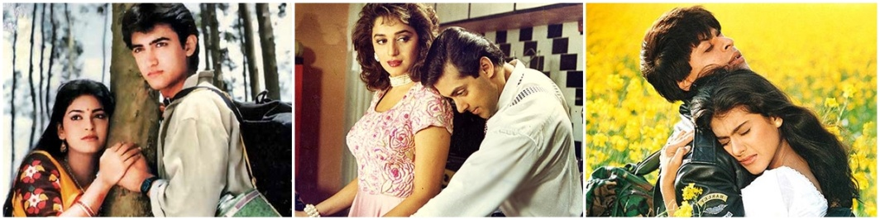‘Qayamat Se Qayamat Tak’ (1988), ‘Hum Aapke Hain Kaun’ (1994), and ‘Dilwale Dulhania Le Jayenge (1995) are notable love-stories and drama, as are their long titles
A depression shadowed over Bollywood in the early 80s. It was also the time when home video began gaining popularity. However, in the late of 80s, age of romantic movies returned when numerous hit love-stories and family-oriented movies starring Amir Khan, Salman Khan, and Shahrukh return Bollywood to happy days again. Meanwhile Govinda and Akshay Kumar leaded the comedy and action genres.
When the human kind entered the new millennium, Bollywood movies began to reflect the change. Movies like ‘Koi.. Mil Gaya’, ‘Dhoom’, ‘Dil Chahta Hai’, ‘Company’, ‘Aankhen’, ‘Krrish’ showed modernness in their story-line and visual representation.
Music which has been an important part the Bollywood movies, noticed a change in this era after the entrance of digital music technologies. Music sales used to make a part of earning in the past, but piracy reduced this profit considerably. As a result, songs were then aimed to be aggressive to aid the promotion of the films rather than record sales.
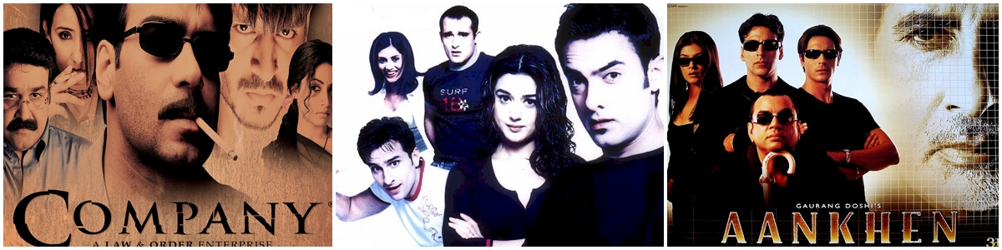‘Company’ (2002), ‘Dil Chahta Hai’ (2001), and ‘Aankhen’ (2002) marked the entrance of Bollywood in the new millennium
After 2010, visual representation turned more mature, topics have become diverse, however Masala and romantic movies are still on the top. It is the age of multiplexes and malls when the profits from movies have raised tremendously. Big production houses and big star caste are enough to make a movie blockbuster regardless the content. Meanwhile, Hollywood is also registering a stronger presence in the Indian market, as more viewers are looking for movies other than Masala and Bollywood brand love-stories.
A good sign for Bollywood is that several non-mainstream film directors have become well known and they are able to make films with bigger budgets. Bollywood will have to compete with Hollywood in Indian market in the future-not-so-distant. Bollywood has to prepare for the upcoming war.
Source: GoSeeFeel: 2015. Introduction to Bollywood. http://goseefeel.com/india/brief-bollywood-introduction/, last updated April 22, 2015.

Forget Game of Thrones, This Might Be the Most Watched TV Show of All Time


Aditi Mukherjee
While Indian television is full of family soap operas, there is one biweekly show airing on DD National that even puts American TV show Game of Thrones’ popularity to shame! Main Kuch Bhi Kar Sakti Hoon (or ‘I, a Woman, Can Achieve Anything’) is a Hindi edutainment show that tackles topics like female foeticide, early marriage, pregnancy spacing and so on. Here’s what you need to know about the most popular show.
Main Kuch Bhi Kar Sakti Hoon (MKBKSH) has had over 400 million views across 50 countries, while Game of Thrones can ‘only’ boast more than 300 million views across six seasons. MKBKSH is also popular on numerous radio channels, with more than 60 million listeners. It shows Dr. Sneha Mathur (Meinal Vaishnav) working in one of the busiest cities in India, Mumbai. However, she leaves her lucrative city career to bring grassroots-level change to rural India.
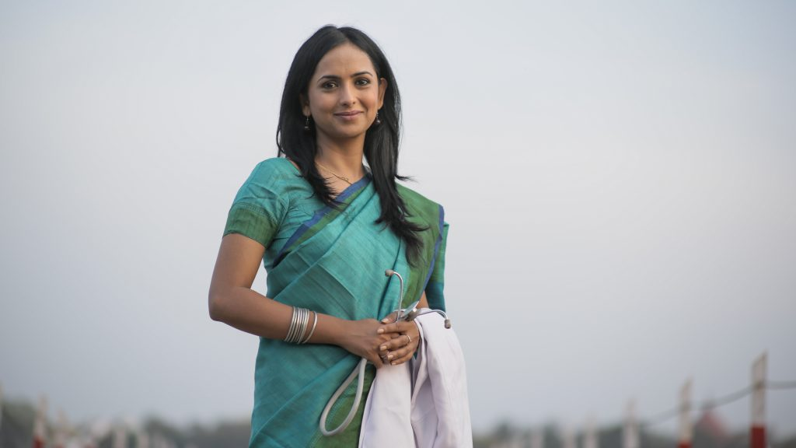
India’s rural population have little or no knowledge about contraception and sexual health, a scenario that Poonam Muttreja, the Executive Director of Population Foundation of India, wanted to change. She was encouraged to conceptualise the show in 2011 after the encouraging response to Haule, Haule, a show developed by the Ministry of Health and Welfare.
With the help of communication expert Dr. Arvind Singhal from the University of Texas El Paso, the team used a ‘positive deviance’ approach. That is, the positive behaviour of individuals was amplified, and shown as the norm and not the exception. Poonam Muttreja is still surprised at the positive response MKBKSH has evoked, especially from men and young women. On-the-ground campaigns in Bihar and Madhya Pradesh, and lots of championing by Bollywood stars and the corporate sector, have helped to increase the show’s impact.
In rural India, it’s common for women to get married at the age of 18. The protagonist of the show, Meinal Vaishnav, had a similar story to tell: “When I passed out of college my parents wanted me to get married. I was mentally and physically abused because I refused to do so.” Meinal traveled across India, working in travel based companies and building her career, to finally find herself in the role of Dr. Sneha Mathur. She says: “I never took acting seriously, even though my friends always encouraged me to take it up. But, now I live and breathe Dr. Sneha Mathur. I would want to be associated with MKBKSH for as long as the producers want”.
To become the world’s most watched television show is quite a feat, as it receives stiff competition from across the world. MKBKSH has broken boundaries, fought odds and reached this stage in just three years since it first aired. When one compares it to shows like Game of Thrones, MKBKSH is a serious show with social messages and no fancy Computer Generated Imagery! What works for the show is the fact that the vast Indian audience can relate to it.
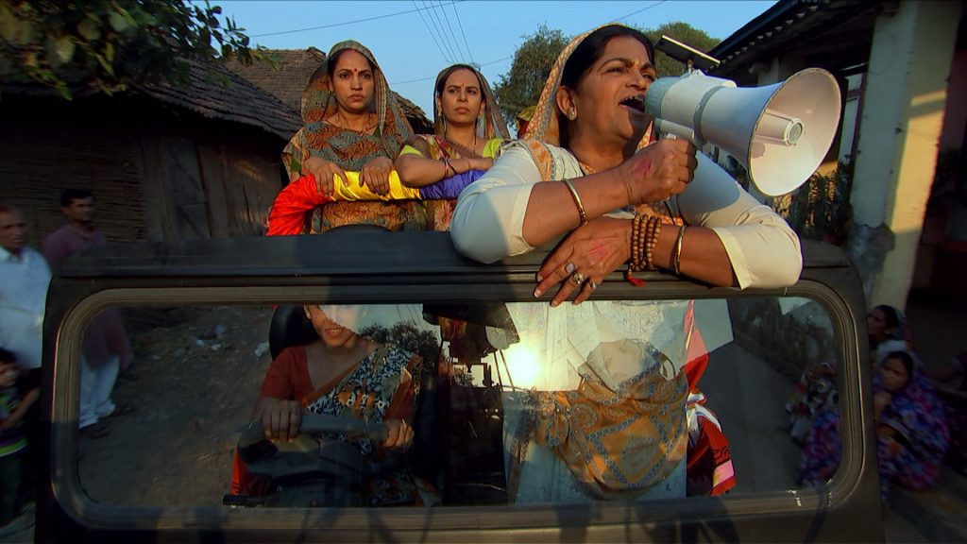
A still from Main Kuch Bhi Kar Sakti Hoon / MKBKSH PR Team
MKBKSH’s third season is currently under development. In Season 3 they aim to focus on the youth, in an effort to change patriarchal social norms and practices that promote gender bias and gender inequality. Mental health will also be addressed in the upcoming season.
Source: Mukherjee, A.: 2017. Indian TV show. https://theculturetrip.com/asia/india/articles/an-indian-television-show-becomes-worlds-most-watched-beating-game-of-thrones/, last updated June 19, 2017.
Follow-up tasks:
- Characterize MKBKSH. Is it surprising to see such a progressive show in India?

- Try to outline and compare the main features of American, Indian and Czech cinematography.

